2.7 Compute the probability density function (PDF) of *ST*

2.7.1 Implementation

Steps of implementation:

1. Assert validity of function input arguments.
2. Pre-allocate space to the vector of PDF values.
3. Create a $3×k$ matrix of *Ks-h, Ks* and *Ks+h,* where *k* is the length of *Ks*, h is 0.0001.
4. Obtain *Vs* using the function *getVol*, and then obtain the forward prices of the call options *Cs* using the function *getBlackCall*.
5. If $K-h<0$, then the PDF value is set to 0. If not, compute the numerical second derivatives using the MATLAB function *diff.*

The approximation of the second derivative used in the function is

$$f^{''}\left(x\right)≈\frac{f\left(x+h\right)-2f\left(x\right)+f(x-h)}{h^{2}}$$

We implement the function with T=0.8, Ks=fwd, using bump size raging from 1e-16 to 1e+0, then plot the PDF value. We can see that the PDF value decreases wiggly at first and becomes stable thereafter. Thus, $h=0.0001$ is set in the function.

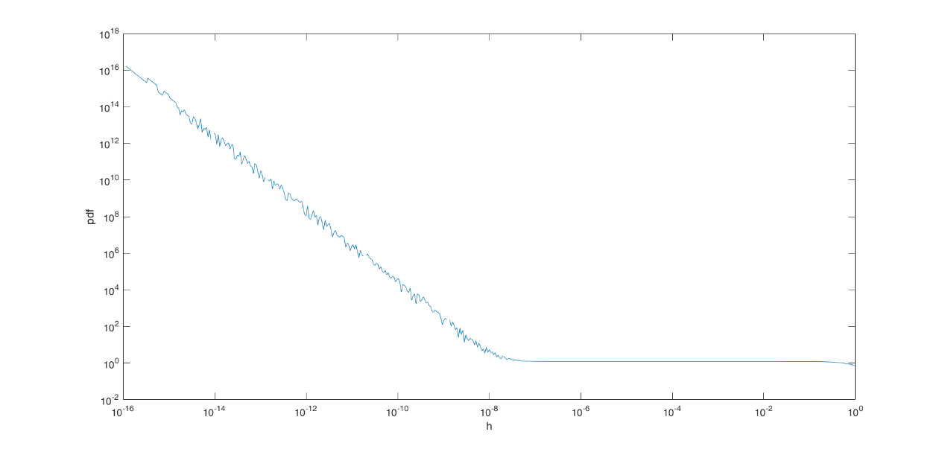

We plot the PDF for each expiry time.

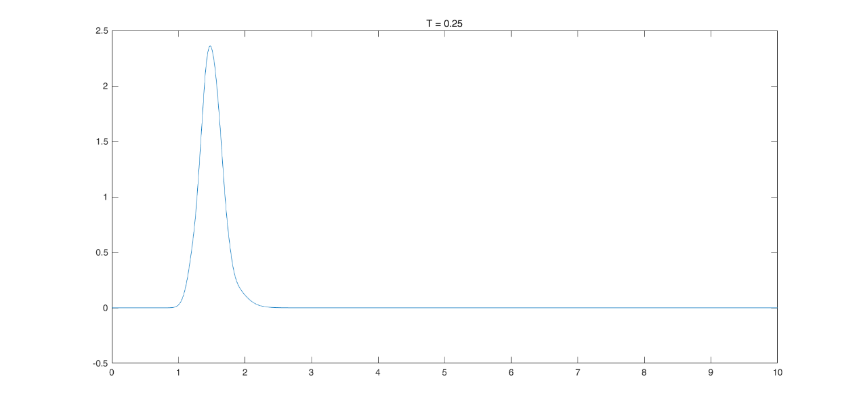

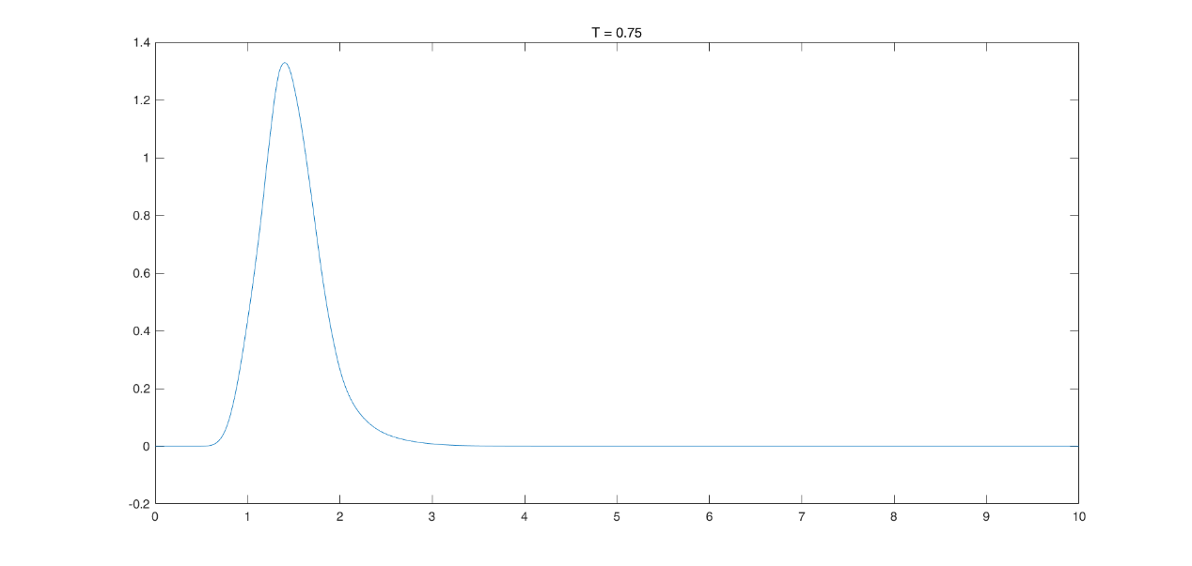

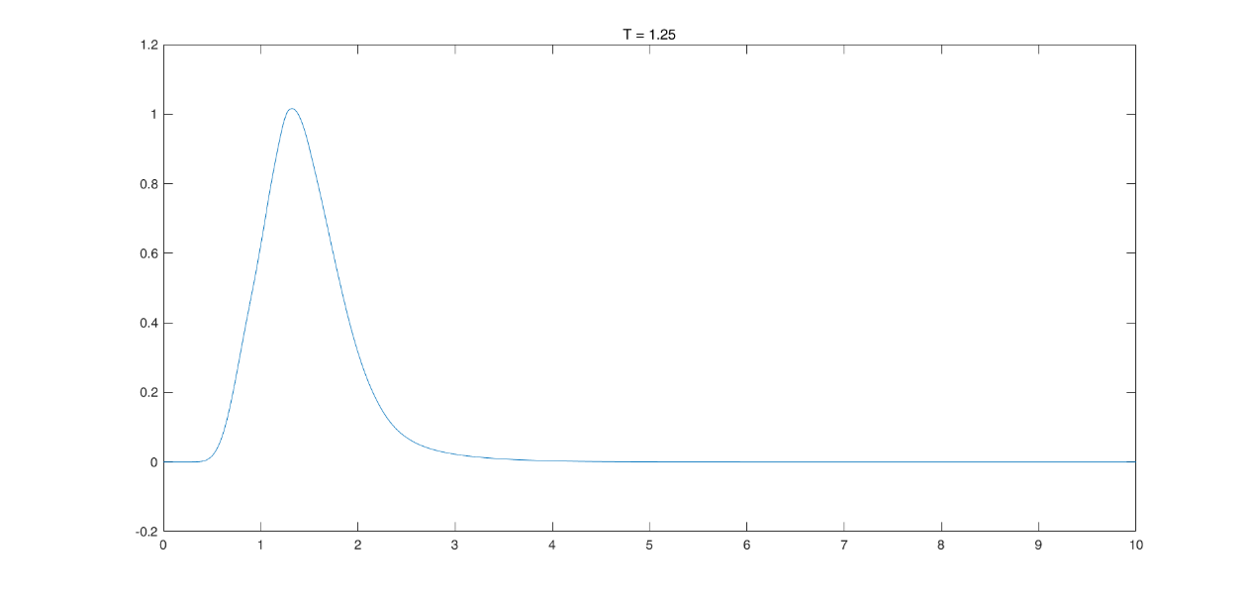

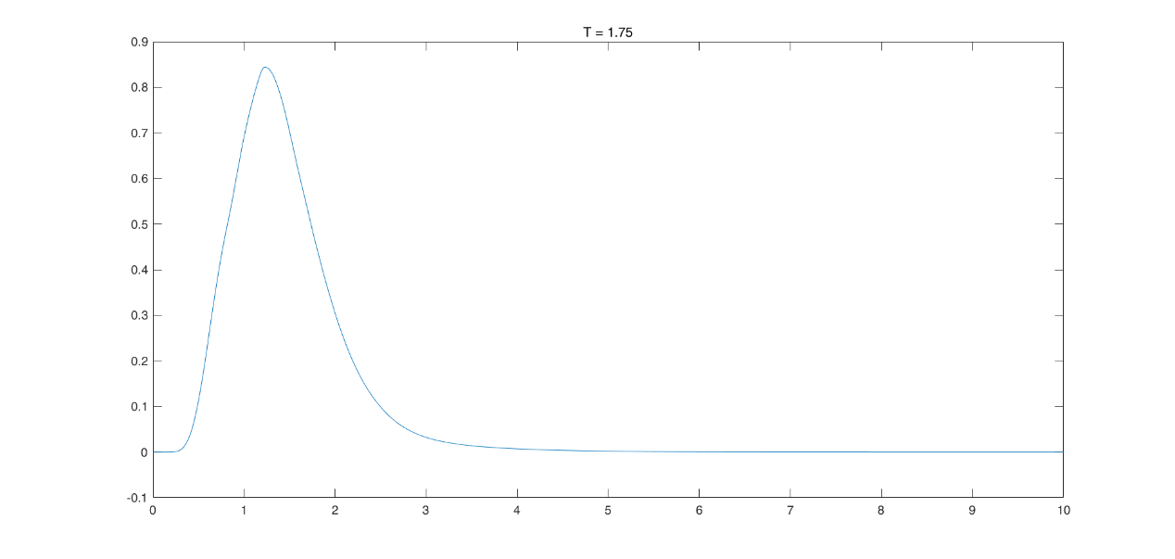

We can see that the PDF for each expiry time behaves like a log-normal distribution as expected. Moreover, for a given volatility surface, the kurtosis of the PDF decreases as the expiry time T increases, which indicates fewer extreme outliers in the distribution.

2.7.2 Tests

We implement the function *testPdf* to test properties of the function *getPdf*. The input argument *eps* specifies the tolerance level of the absolute difference.

First, we test if the integral of the PDF is 1 by using the function *getEuropean* with the input argument payoff = @(x) 1.

Second, we compare the mean of the PDF against the forward spot price. We first compute the mean by using the function *getEuropean* with the input argument payoff = @(x) x, and then obtain the forward spot price by using the function *getFwdSpot.*

When *eps* = 0.0001 is applied, the function *getPdf* pass the tests stated above.

2.8 Compute forward prices of European options

2.8.1 Implementation

Step 1: Assert validity of function input arguments.

Step 2: We create a handle for the integrand $f(x)ϕ(x)$.

Step 3: we use the MATLAB function *integral* to compute numerical integration. If the number of the input arguments is smaller than 4, or the fourth input argument *ints* is [0, +Inf], we compute the integration from 0 to Inf. If a repartition of the integration interval is specified, then we compute the integration in sub-intervals separately, and obtain the sum.

2.8.2 Tests

We implement the function *testPriceEquality* to compare the forward price of a call option obtained with Black formula against the price obtained by numerical integration. The input argument *eps* specifies the tolerance level of the absolute difference.

When *eps* = 0.0001 is applied, the function *getEuropean* pass the test.